1. Configure your user name and email.

git config - -global user.name = “Sumit Yadav”

git config - -global user.email = [sumit.yadav@rapidops.com](mailto:sumit.yadav@rapidops.com)

1. Clone repo of your name from GitHub to the local system.

Cmd = git clone “address”

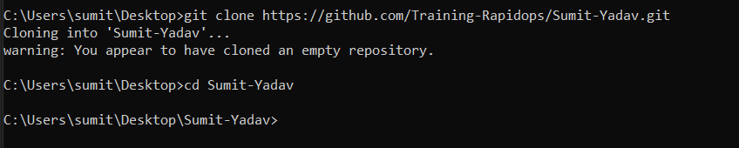

1. Create a file inside the repo, and make your first commit "My First Commit".

Cmd = echo “sumit-yadav” >> README.md

Git add .

Git commit -m “My first Commit”

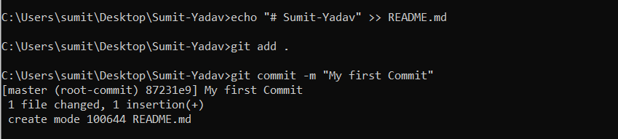

1. Create and switch to the branch 'test/development' (create from the master branch and it should be from origin).

Cmd = git branch test , git checkout test

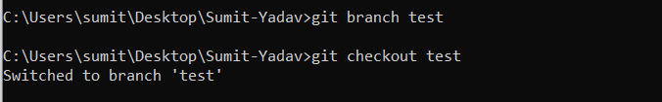

1. Add a file in this branch and commit your changes with the message "Practice started in test branch".

Cmd = echo “# this is test branch” >> test.txt



Cmd = git add test.txt , git commit -m “Practice Started in Test Branch”

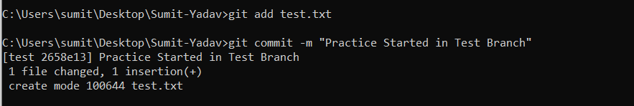

1. Now push your changes and this branch to the remote.

Cmd = git push origin test

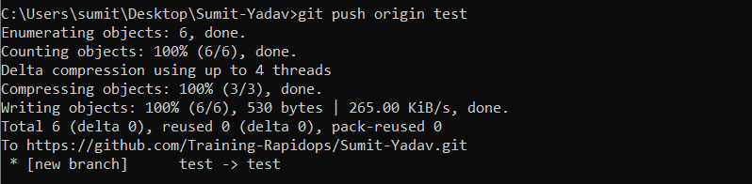

1. Go to your GitHub repository and create a pull request to merge this branch in master. Also, add Ravindra & your mentor as reviewers.

Created Pull Request And merged with master on Github

1. Go to your GitHub repository and create a pull request to merge this branch in master. Also, add Ravindra & your mentor as reviewers.

Forked it on my github

1. Make a change in the template.html file by adding 'author: {your-name}' and add commit 'Author updated by {your-name}'.

Cmd git add . ,

git commit -m “Author updated by Sumit Kumar Yadav”

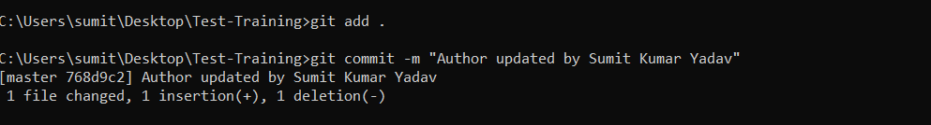

1. Make a change in the template.html file by adding 'author: {your-name}' and add commit 'Author updated by {your-name}'.

Made a Pull request on github

1. Come back to your repo, where you create a branch 'practice' and add 3 commits then rebase it with the master

Cmd = git branch practice, git checkout practice, echo for file create & git commit cmd for commit

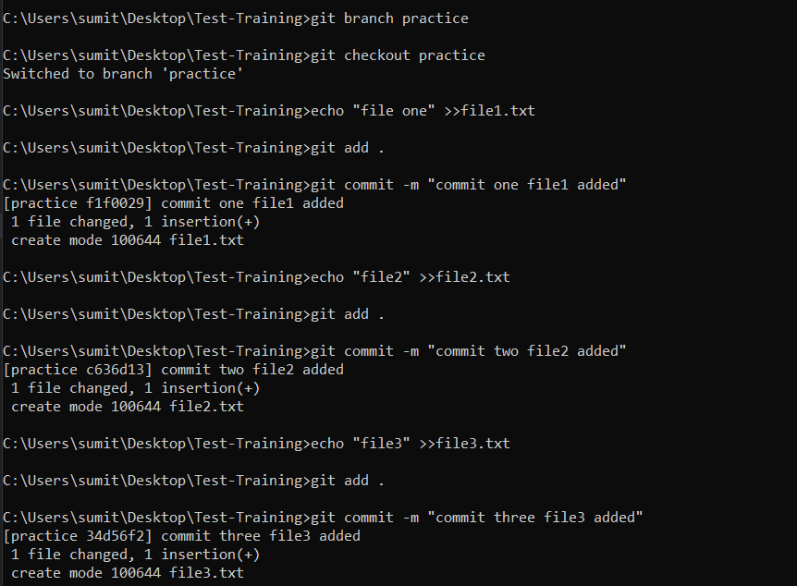

Cmd = git rebase master

git checkout master

git rebase practice

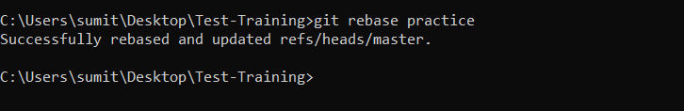

**All three commits are rebased with Master**

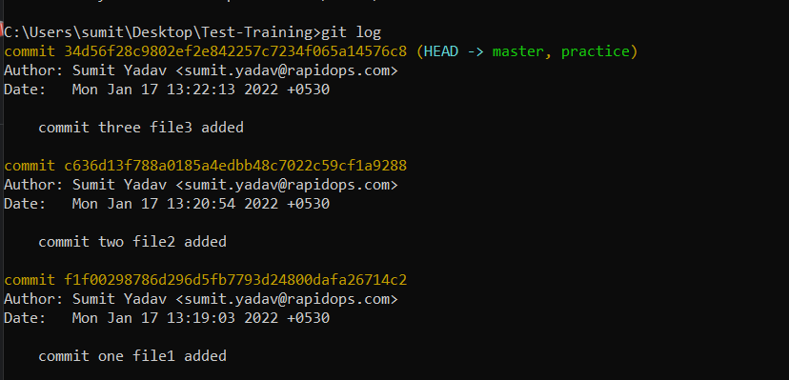

1. Push your changes to remote, then Add 3 commits again and squash them into the first commit by keeping the message "Rebase squash done".

Cmd = git push origin master

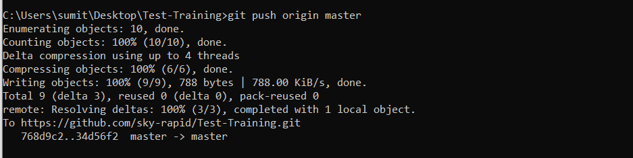

Cmd = git rebase -i HEADE~3

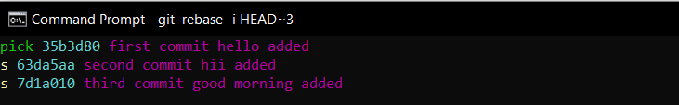

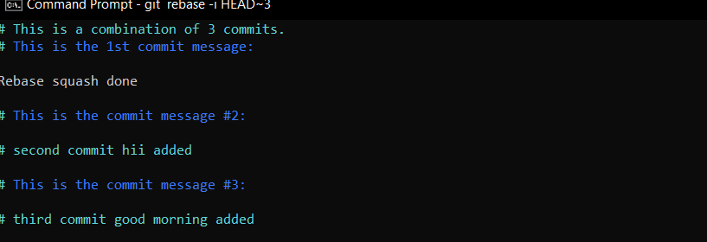

Rebase done

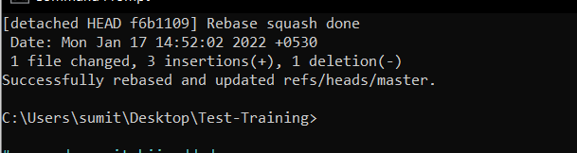

1. Now revert these changes but note that the changes must be retained in the commit history. (use default revert commit message)

Cmd = git revert “commit id”

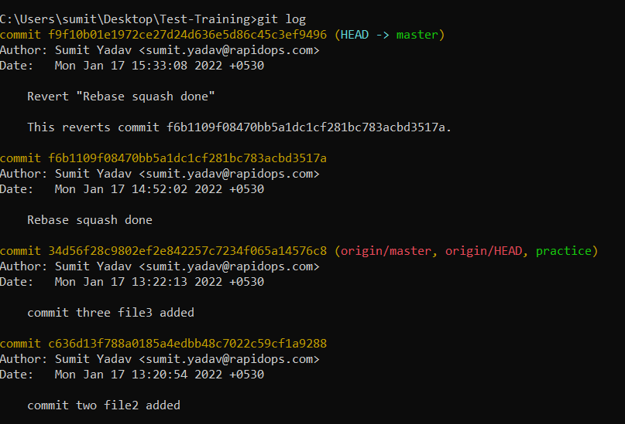

1. Reset your last commit without losing the changes and then commit with the message "Finished revert with staging changes".

**Cmd = git reset --soft HEAD~1**

Forget to take screenshot cleared terminal

1. Create one commit then perform a hard reset such that you're back to the commit with the message "Rebase squash done".

Cmd = git reset –hard HEAD~1



1. Create a file index.html, and add it to the staging index then stash it.

Cmd = git stash

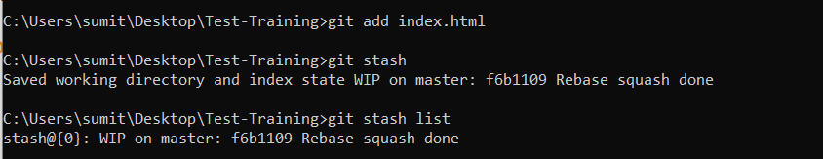

1. Check the list of stash, what changes are there in the stash, then bring your changes from stash.

Cmd = git stash list

git stash pop 0

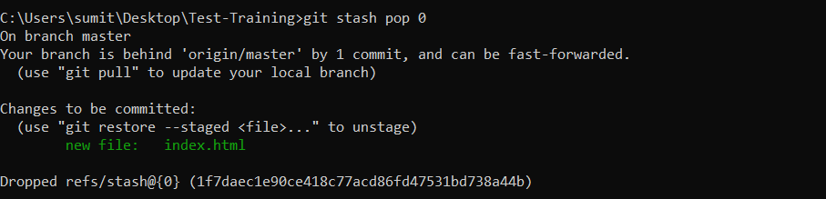

1. Commit with a message "Revert, Reset & Stash done".

Cmd = git commit -m “Revert , Reset & Stash done”

